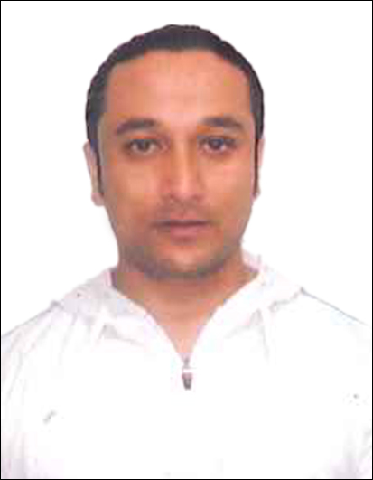
CURRICULUM VITAE

KUNAL SUNDAS
Mail: kunalsundas78@gmail.com
Mobile:0501703215
CERTIFIED FITNESS TRAINNER
GOLD GYM DELHI

Objective: To seek the position of physical fitness instructor

SUMMARY OF QUALIFICATION
- Performed work experience as Gym instructor at eminent gyms like GOLD GYM and SARKAR FITNESS.
- In depth knowledge of various physical process and their interrelation.
- Vast knowledge regarding using method of the different physical abnormalities (Pain, Cramps) etc. arising while exercise.
- Group experience and the fat burning exercises like HIIT according to the person need.
- Detailed knowledge of all kinds of diet food and their applicability according to the body type.
- Excellent communication skills and instructing ability.
- Good Hand work at computer and the internet search engines.

PROFESSIONAL EXPERIENCE
- Personal Trainer in GOLD GYM
- Senior Personal trainer in SARKAR FITNESS

ACADEMIC EDUCATION
- Graduated from (N.B.U) India

EXTRA CURRICULA’S
- Participant in the 50th Senior National Body Building Championship, Goa.
- 3rd Himalayan Classic Body Building Championship 1st place and the best poser.
- First place in the Mr. Himalay Body building Championship 60kg category.
- Strongest man of kalimpong lifted 140kg in Squat .

DECLARATION
I hereby certify that the above information are true and correct according to the best of my knowledge & My Experience. If selected I assure that I would perform to the best of my abilities, early awaiting a Positive response.

KUNAL SUNDAS BHIM

